# APERC Transport model documentation

This document is intended to help you understand the transport model and some details you may be wondering about when using the model.

# APERC Transport model

The Aperc transport model is intended to provide a simple to use and understand model of transport energy economies. The input data has been limited to what was deemed essential. It’s structure is designed to be intuitive, and the code, easy to read.

The model’s input data is as follows, split into base year data and growth rate data:

And then below is the different categories for which we need that data (except, where ‘road only’ is specified for a measure then air, ship and rail are not needed)

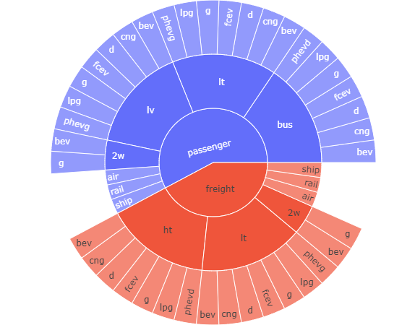

Below is a schema that details the columns used in the model, split into **change state** **n** and **base year + n** to try and give some idea as to the process. You can think of the model as a big ‘for loop’ that will iterate through each year from the base year to the final forecasted year, calculating the values for each year using the values from the year before, growth rates and user defined values/adjustments. The change state dataframe is just the dataframe where all the operations take place before finalizing the new year’s values.

Activity, Energy and stocks are the data types that are usually analysed after the model has been run, but the other input data is just as important for forecasting the data.

# Model simulation.xlsx

There is a file in the same folder as this that shows how the model works for two years. This can be used to get an idea of how the model works if you don’t understand code. I haven’t double checked whether it’s output matches the model so I wouldn’t put 100% trust in it.

# Transport data system

Transport data is difficult to collect because of the need for so many different measures and unique categories. There are few publicly available central sources of data, so keeping track of data sources for most datasets is important. (i.e. labelling where travel km for economy X is from).

These issues lead to a major difficulty for the user of the transport model to acquire and use new data because this data are usually of different formats and incomplete.

This leads to a need to maintain a separate project to the transport model for cleaning, aggregating and preparing input data. This is called the **Transport data system**.

There is also consideration of working with iTEM to build a open source transport database to provide a sustainable solution to the data problems.

# Glossary of categories for data used in aperc transport:

|  |  |  |
| --- | --- | --- |
| Category/column name | Description | Format |
| Year |  |  |
| Economy | labelled with APERC naming convention, eg, 01_AUS = Australia. There is a mapping from these codes to their real names in the config/utilities folder. | The same format as the economy labels |
| Transport Type | either 'Passenger' or 'Freight'. | All in lower case |
| Medium | either of ['road', 'air', 'ship', 'rail'] | All in lower case |
| Vehicle Type | if the medium is not road, this is the medium, but if the medium is road, it could be one of ['2w', 'ht', 'lt', 'lv'] or even a new vehicle type | All in lower case |
| Drive | if the medium is not road, this is the medium, but if the medium is road, it can be one of ['d', 'g', 'bev', 'cng', 'phevg', 'phevd', ‘fcev’] or even a new drive type | All in lower case |
| Scenario | One of the scenarios used in the model. | Begins with Capital letter |
| Fuel | Any fuel type used in the transport system. Fuel type named using the APERC naming conventions. The mappings for these to other naming conventions used in APERC should be in ./config/utilities/ | All in lower case |
| Measure | A label to describe what measure the data is in. | All in lower case |

## Measures used in the transport model and their definitions

|  |  |
| --- | --- |
| Activity |  |
| Freight tonne km |  |
| Passsenger km |  |
| Energy |  |
| Energy use by drive type |  |
| Energy demand by fuel type (eg. PHEV's) |  |
| Energy supply by fuel type (eg. biofuel mixing) |  |
| Stocks |  |
| Other factors |  |
| turnover rates | The percent of vehicle stocks removed from the total stocks each year. |
| occupancy and load factors | Depending on transport type, this reflects the average number of people who use a vehicle at a time, or the average tonne’s transported by freight transport, for a given vehicle type. |
| new vehicle efficiency | Defined for the base year only. Then each year it is adjusted by the new_vehicle_efficiency_growth value.  It is the efficiency for the average new vehicle introduced to the vehicle stocks each year, by economy, year, transport type, vehicle type and drive type. Efficiency is calculated as the travel km / energy use. So the higher the efficiency value, the ‘more efficient’ the vehicle is. |
| non road efficiency | We assume there is only 1 stock in the non-road mediums, so the rate that efficiency is improved each year is just a flat growth rate on top of the current efficiency. |
| Demand side fuel mixing | The share of a certain fuel type used in a certain drive type, for a certain vehicle type. This is focused on the demand side, so for any cases where other fuel types are mixed in the supply side, this assumes only the original fuel is used, eg. For biofuel mixing into diesel, the demand side will assume this mixed diesel is just diesel. |
| Supply side fuel mixing | The share of a certain fuel type used in a certain drive type, for a certain vehicle type. This is focused on the supply side so it is only focused on the mixing of fuels into an original fuel type, for example biofuel mixing. |
| User Adjustments | User adjustments are intended to allow for changes to growth rates where the user doesn’t fully understand the effect of the changes? |
| vehicle sales share adjustment |  |
| occupancy and load adjustment |  |
| turnover rate adjustment |  |
| new vehicle efficiency adjustment |  |
| non road efficiency adjustment |  |
| Intermediary measures |  |
| Travel km |  |
| Surplus stocks | If new stocks needed each year is negative then we have too many preexisting stocks. In this case, we will assume that the absolute amount of this negative value of new stocks needed will sit in surplus. This can occur because ??? |
| Activity growth |  |
| Efficiency of surplus stocks | It is important we keep track of this for the surplus stocks. |
| Travel_km_per_stock |  |
| Vehicle_sales_share | The share of drive types for each vehicle type sold, normalized so the sum of shares for each transport type sums to 1. |
|  |  |
|  |  |

## Category definitions

### Vehicle types:

|  |  |
| --- | --- |
| Vehicle type | Description |
| **LT:** | Light truck (fairly flexible definition, ranges from utes to vans) |
| **LV:** | Light vehicle (fairly flexible definition, ranges from small cars to utes) |
| **HT:** | Heavy trucks |
| **2W:** | 2 wheeler. Includes 3 Wheeler |
| **Bus:** | Bus |

### Drive types

(otherwise called powertrain or engine type, I think the most accurate decription is powertrain):

|  |  |
| --- | --- |
| Drive/Engine/Powertrain | Description |
| BEV: | Battery electric vehicle |
| PHEV: | plug-in hybrid electric vehicle. Currently differentiated by whether it runs on petrol (g) or diesel (d) because it is required in the model. PHEV’s include all hybrid types currently, even though there are many types, defined by their ratio of electricity/oil usage. |
| FCEV: | hydrogen fuelled, fuel cell electric vehicles. Basically anything powered with hydrogen. |
| G: | petrol Internal combustion vehicles |
| D: | diesel Internal combustion vehicles |
| CNG: | powered by Compressed natural gas, but may also include other gas types like LNG or LPG. From my knowledge the majority of the usage of this is in buses. |

# Units

Currently it is not clear how the data’s units are defined. It is assumed that by cross refereincing the data the user can learn this easily. They are based on the data used for the 8th edition outlook.

# Osemosys integration

The transport model output is currently intended to be used by the APERC osemosys model, so the transport model needs to put its output data into the format needed by this.

So the outputs are:

**Accumulated Demand** = the total activity, by transport type, vehicle type and drive type.Please note that it doesn’t reflect the amount of activity by fuel type.

**Input Activity Ratio** = not efficiency, but like efficiency. Calculated as energy by fuel type, divided by Accumulated Demand, so it indicates the share of energy in each fuel type, drive type category, for each unit of activity in each drive type.

# Model simulation

The spreadsheet model_simulation.xlsx is intended to simulate the way the transport model works so that you can more easily understand it than reading the code. I am endeavoring to keep it up to date with the actual model.

# Comparing the 8th edition model vs this:

Below is the schema that was used for the 7th and 8th edition models. An effort has been made to provide more useful information than this by focusing on measures used rather than the categories of data included.

Generally it seems the models have the same inputs, the real change with this model is an effort to make it more easily usable. However, the output data is not the same. Because of the issues with the code in the 8th edition, its not expected that we will be able to make the new model replicate the results from the 8th edition exactly (even using the same inputs). Below is a graph of total stocks, activity and energy per vehicle type / drive type combination:

# How to use the model:

Run the integrate.py file. Make sure the input data is available and in the same format as is in the Github currently. Follow the Readme for setup details. If worst comes to worst, please feel free to just contact me (finn) or raise an issue in the Github page.

# Visualising data

* It’s important that it is easy to inspect the outputs from the system.
  + Useful for my own analysis
  + Useful for communicating with the economy’s
* Big effort is being put towards developing easy-to-use plotting of charts I expect I will use often. The code to create these will be messy until I find out what charts are most useful to create for all scenarios. However it may be that I continue making messy visualization files.
* The code is in ./other_code/
* Charts are saved in plotting_output. There are ./static/ folders for png versions of the Plotly charts which are produced in html. However the HTML files are much more useful. The static versions are really there as records of what has/hasn’t been produced, since they are often rendered in a way that is difficult to read.
* This is super messy so explore at your own risk

# Useful sources

# To do list:

**Estiamtion of international transport use of bunkers supply** – probably calculate the average efficiency of international transport and then calcalate total activity using this energy supply. There is also a small chance that the ESTO/EGEDA team has estimated this kind of data so we could use their estimates.

**Pipeline transport** – it is unclear how this was done in the 7th and 8th editions. Perhaps we could see if there are any estimates already done within APERC for historical data. Otherwise some sort of factor will need to be found. The forecasts will be simple.

**Capital costs model –** it is intended that this would also provide a space for looking at how many new EV’s are needed for an economy to reach its goals, e.g. California 100% by 2035. Intention is that battery shortages are looked into.

**Integration of lifecycle emissions?**

**Input data system**

# Notes:

# Working with iTEM to develop a sustainable input data source

[Website](https://transportenergy.org/)

[Transport energy database](https://github.com/transportenergy/database/)

After talking to the leaders of this project they instructed that I should post an issue in the GitHub so that they could see how they could help as well as provide the database with a task and a way for it’s activity to show up on google etc.

# My self-introduction on the iTEM Slack channel:

Hi all,

I just wanted to introduce myself as someone new to this group and the transport modeler at [APERC](https://aperc.or.jp/reports/outlook.php). I wanted to become a part of this group to better learn how to do my modelling and if there is any way, help others. For me the transport database has a lot of potential to reduce time updating data.

And here is the transport model I have recently built. It’s a relatively simple I think, designed for the APERC focus on knowledge based modelling. The intention was to build a tool that is suited to being reused for consecutive outlooks, many scenarios, and future researchers. It’s still a work in progress but if you want to talk about it, give advice or even use it, please feel free.

# My post:

# Large version

Hi I have been intending to use the iTEM database to gather input data for our APERC transport model.

Below is a detailed description of the data I am looking for the model. I am hoping that there may be locations to find large sets of this data, say for multiple economies.

## APEC countries

Oceania:

Australia, New Zealand, Papua New Guinea

Southeast Asia:

Brunei Darussalam, Malaysia, Indonesia, Philippines, Singapore, Thailand, Viet Nam

Americas:

Canada, Chile, Mexico, USA, Peru

East Asia:

China, Hong Kong, Chinese Taipei (Taiwan), Japan, Korea

Russia

## Years:

* To keep it simple, all years that are available would be useful.
  + Later years are better
  + And realistically we only need one year of data for each category

## Transport categories:

The following are what we currently have our data broken into but I’m trying to keep things flexible according to what data is available ([glossary for the acronyms](https://github.com/asia-pacific-energy-research-centre/transport_model_9th_edition/wiki/Glossary))



## Measures:

For the base year, our model uses the following variables:

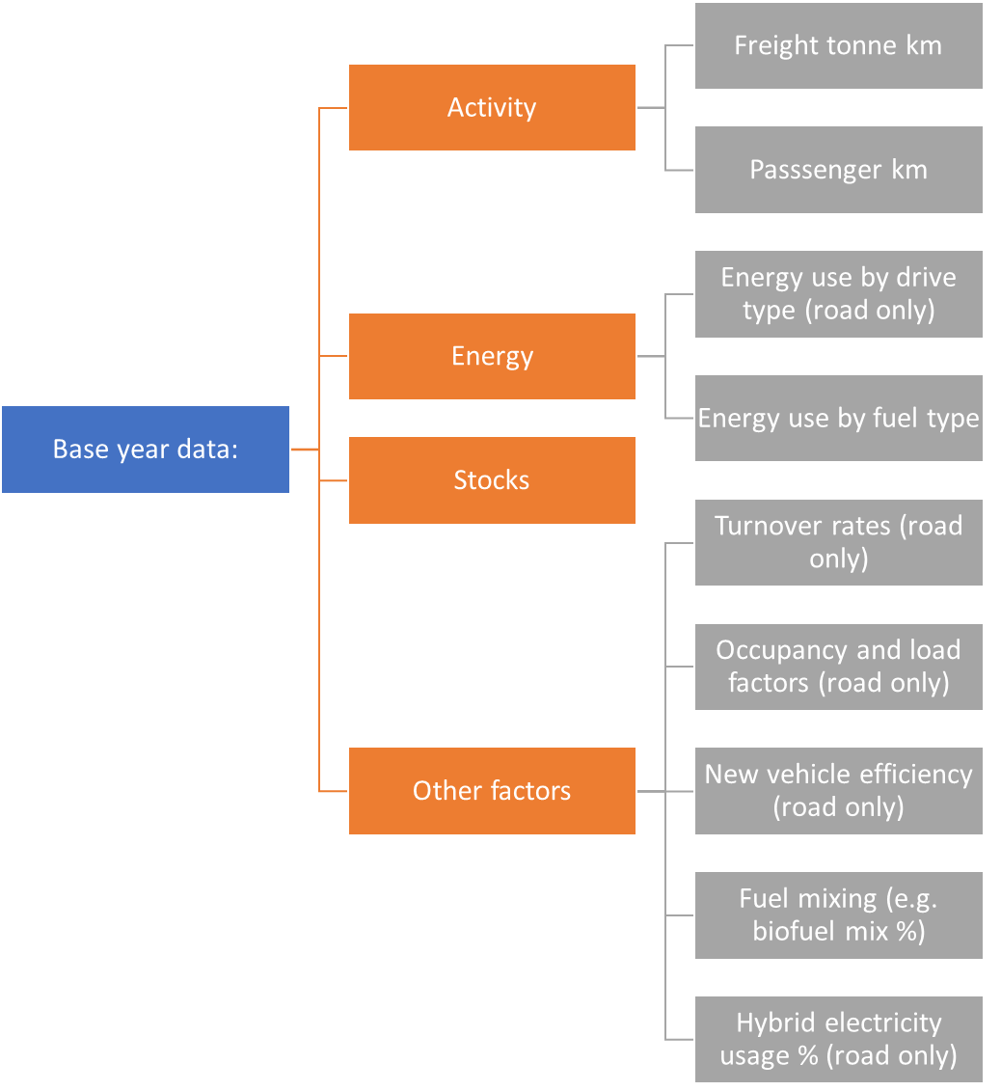

And then it would be good to have a reasonable baseline for the following growth rates (which we will adjust according to the scenario we project):

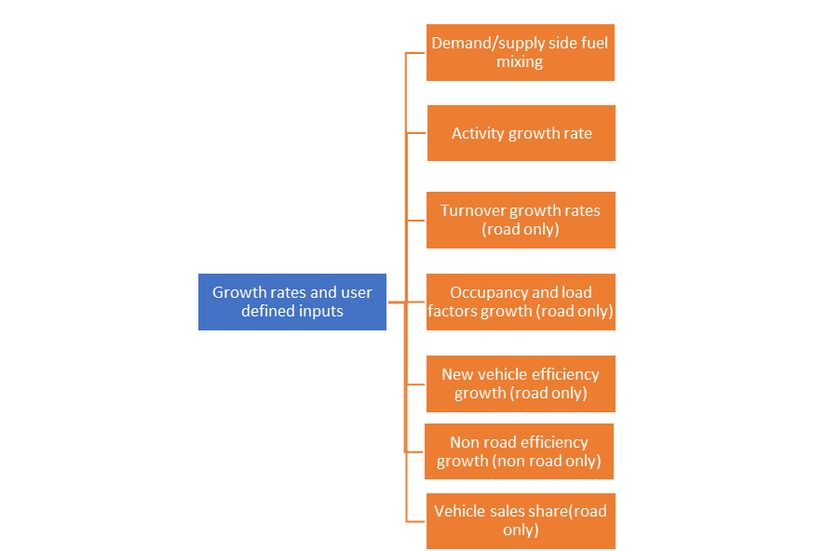

## Large datasets I already have been using:

[ATO (Asian Transport Outlook) Dataset](https://asiantransportoutlook.com/) – large dataset for Asia + Oceania. Gathered from lots of individual sources.

[APERC EGEDA Database](https://www.egeda.ewg.apec.org/egeda/database_info/index.html) – energy use for all fuel types but only the total energy use in each economys transport sector. Gathered from each economy’s government.

# Shortened version

Hi, I have been intending to use the iTEM database to gather input data for our APERC transport model.

Data from any period is useful, but the later the better.

Below is a tree diagram of the data I am specifically looking for, and how it fits into our model.

Following that are details about the different categories the data would be broken into, if available.

## Data I am looking for and how it fits into the model (grey boxes are the actual values I need)

## APEC countries that we need the data for

Oceania:

Australia, New Zealand, Papua New Guinea

Southeast Asia:

Brunei Darussalam, Malaysia, Indonesia, Philippines, Singapore, Thailand, Viet Nam

Americas:

Canada, Chile, Mexico, USA, Peru

East Asia:

China, Hong Kong, Chinese Taipei (Taiwan), Japan, Korea

Russia

## Transport categories:

The following are what we want the data we get broken into, but I’m trying to keep things flexible according to what data is available ([glossary for the acronyms](https://github.com/asia-pacific-energy-research-centre/transport_model_9th_edition/wiki/Glossary)). So, if there are datasets but only for parent categories (eg. Passenger/freight or Passenger lv’s) then we will take those!

## Large datasets I already have been using:

[ATO (Asian Transport Outlook) Dataset](https://asiantransportoutlook.com/) – large dataset for Asia + Oceania. Gathered from lots of individual sources.

[APERC EGEDA Database](https://www.egeda.ewg.apec.org/egeda/database_info/index.html) – energy use for all fuel types but only the total energy use in each economys transport sector. Gathered from each economy’s government.

I also have a series of [individual links to smaller data sources here](https://github.com/H3yfinn/transport_data_system/wiki/Data-sources) but I don’t want to clog things up here.

## Finally

I understand that that is a lot of data/detail. I’m happy to shorten it but I also guess that the answers to this will help structure other discussions or answer other questions. And I’m happy to buy anyone a virtual coffee if they want to talk online about this!

# Sources:

Data I know you have:

Data I already have:

Data for multiple countries: stock [https://www.oica.net/category/vehicles-in-use/](https://fra01.safelinks.protection.outlook.com/?url=https%3A%2F%2Fwww.oica.net%2Fcategory%2Fvehicles-in-use%2F&data=05%7C01%7CMatteo.CRAGLIA%40itf-oecd.org%7C4def8789be8945a3a40d08da5a71fb66%7Ca314ecc9ae804c4daf551584d542db16%7C0%7C0%7C637921744072749126%7CUnknown%7CTWFpbGZsb3d8eyJWIjoiMC4wLjAwMDAiLCJQIjoiV2luMzIiLCJBTiI6Ik1haWwiLCJXVCI6Mn0%3D%7C3000%7C%7C%7C&sdata=870yiV6nBN4qIrZzi2U1Wtc1ptQ%2FJQjXA1mAQ39fazs%3D&reserved=0) sales: [https://www.oica.net/category/sales-statistics/](https://fra01.safelinks.protection.outlook.com/?url=https%3A%2F%2Fwww.oica.net%2Fcategory%2Fsales-statistics%2F&data=05%7C01%7CMatteo.CRAGLIA%40itf-oecd.org%7C4def8789be8945a3a40d08da5a71fb66%7Ca314ecc9ae804c4daf551584d542db16%7C0%7C0%7C637921744072749126%7CUnknown%7CTWFpbGZsb3d8eyJWIjoiMC4wLjAwMDAiLCJQIjoiV2luMzIiLCJBTiI6Ik1haWwiLCJXVCI6Mn0%3D%7C3000%7C%7C%7C&sdata=ESb1qQly8Vm131R7wvW1k04Lrc554U0r85pTDnGnCmM%3D&reserved=0) and from here [https://data.adb.org/dataset/asian-transport-outlook-database](https://fra01.safelinks.protection.outlook.com/?url=https%3A%2F%2Fdata.adb.org%2Fdataset%2Fasian-transport-outlook-database&data=05%7C01%7CMatteo.CRAGLIA%40itf-oecd.org%7C4def8789be8945a3a40d08da5a71fb66%7Ca314ecc9ae804c4daf551584d542db16%7C0%7C0%7C637921744072749126%7CUnknown%7CTWFpbGZsb3d8eyJWIjoiMC4wLjAwMDAiLCJQIjoiV2luMzIiLCJBTiI6Ik1haWwiLCJXVCI6Mn0%3D%7C3000%7C%7C%7C&sdata=70%2FGJiYNZ2GrV0w%2FFDpVPdDJtxFNmZ%2B3UW43s29%2FBek%3D&reserved=0)

Japan: New regs from here [https://jamaserv.jama.or.jp/newdb/eng/index.html](https://fra01.safelinks.protection.outlook.com/?url=https%3A%2F%2Fjamaserv.jama.or.jp%2Fnewdb%2Feng%2Findex.html&data=05%7C01%7CMatteo.CRAGLIA%40itf-oecd.org%7C4def8789be8945a3a40d08da5a71fb66%7Ca314ecc9ae804c4daf551584d542db16%7C0%7C0%7C637921744072749126%7CUnknown%7CTWFpbGZsb3d8eyJWIjoiMC4wLjAwMDAiLCJQIjoiV2luMzIiLCJBTiI6Ik1haWwiLCJXVCI6Mn0%3D%7C3000%7C%7C%7C&sdata=vdMJbt4YM9thC8X9qDHGg%2BITVSvEdWr8giqjN4J8VLQ%3D&reserved=0) and here [https://www.jaia-jp.org/english-stat/?y=2020&c=stat1](https://fra01.safelinks.protection.outlook.com/?url=https%3A%2F%2Fwww.jaia-jp.org%2Fenglish-stat%2F%3Fy%3D2020%26c%3Dstat1&data=05%7C01%7CMatteo.CRAGLIA%40itf-oecd.org%7C4def8789be8945a3a40d08da5a71fb66%7Ca314ecc9ae804c4daf551584d542db16%7C0%7C0%7C637921744072749126%7CUnknown%7CTWFpbGZsb3d8eyJWIjoiMC4wLjAwMDAiLCJQIjoiV2luMzIiLCJBTiI6Ik1haWwiLCJXVCI6Mn0%3D%7C3000%7C%7C%7C&sdata=sgefpOOXzzLe%2F27krhVHYUHtk27A4Vth4KwkGzJwIE8%3D&reserved=0) stock data from here [https://www.jama.org/wp-content/uploads/2020/08/mvs2020.pdf](https://fra01.safelinks.protection.outlook.com/?url=https%3A%2F%2Fwww.jama.org%2Fwp-content%2Fuploads%2F2020%2F08%2Fmvs2020.pdf&data=05%7C01%7CMatteo.CRAGLIA%40itf-oecd.org%7C4def8789be8945a3a40d08da5a71fb66%7Ca314ecc9ae804c4daf551584d542db16%7C0%7C0%7C637921744072749126%7CUnknown%7CTWFpbGZsb3d8eyJWIjoiMC4wLjAwMDAiLCJQIjoiV2luMzIiLCJBTiI6Ik1haWwiLCJXVCI6Mn0%3D%7C3000%7C%7C%7C&sdata=swmKTrtZDf6ylomQJSJWESe%2BV0fQ2XPXUtQ456NHoUU%3D&reserved=0)

Korea: stock from [https://kosis.kr/eng/](https://fra01.safelinks.protection.outlook.com/?url=https%3A%2F%2Fkosis.kr%2Feng%2F&data=05%7C01%7CMatteo.CRAGLIA%40itf-oecd.org%7C4def8789be8945a3a40d08da5a71fb66%7Ca314ecc9ae804c4daf551584d542db16%7C0%7C0%7C637921744072749126%7CUnknown%7CTWFpbGZsb3d8eyJWIjoiMC4wLjAwMDAiLCJQIjoiV2luMzIiLCJBTiI6Ik1haWwiLCJXVCI6Mn0%3D%7C3000%7C%7C%7C&sdata=Pm3%2BTd3qG6OL8EZF5RJuYbi1WPAbXQ87%2F16iygGZJcI%3D&reserved=0)  -> Transport and Traffic -> Total Registered Motor Vehicles and from OICA

Singapore: stock and sales [https://www.lta.gov.sg/content/ltagov/en/who_we_are/statistics_and_publications/statistics.html](https://fra01.safelinks.protection.outlook.com/?url=https%3A%2F%2Fwww.lta.gov.sg%2Fcontent%2Fltagov%2Fen%2Fwho_we_are%2Fstatistics_and_publications%2Fstatistics.html&data=05%7C01%7CMatteo.CRAGLIA%40itf-oecd.org%7C4def8789be8945a3a40d08da5a71fb66%7Ca314ecc9ae804c4daf551584d542db16%7C0%7C0%7C637921744072749126%7CUnknown%7CTWFpbGZsb3d8eyJWIjoiMC4wLjAwMDAiLCJQIjoiV2luMzIiLCJBTiI6Ik1haWwiLCJXVCI6Mn0%3D%7C3000%7C%7C%7C&sdata=48cthJA9oFg%2BYLnrChW9GmXotpYSbYciP7UNZFkHfDM%3D&reserved=0)

Australia: stock from [https://www.abs.gov.au/](https://fra01.safelinks.protection.outlook.com/?url=https%3A%2F%2Fwww.abs.gov.au%2F&data=05%7C01%7CMatteo.CRAGLIA%40itf-oecd.org%7C4def8789be8945a3a40d08da5a71fb66%7Ca314ecc9ae804c4daf551584d542db16%7C0%7C0%7C637921744072749126%7CUnknown%7CTWFpbGZsb3d8eyJWIjoiMC4wLjAwMDAiLCJQIjoiV2luMzIiLCJBTiI6Ik1haWwiLCJXVCI6Mn0%3D%7C3000%7C%7C%7C&sdata=ipkoHai4yT3G7cuSYLv6Nqayng3X74mfYQ0wAIcCYJg%3D&reserved=0) and from ITF statistics

New Zealand: [https://www.transport.govt.nz/statistics-and-insights/fleet-statistics/2019-annual-fleet-statistics/](https://fra01.safelinks.protection.outlook.com/?url=https%3A%2F%2Fwww.transport.govt.nz%2Fstatistics-and-insights%2Ffleet-statistics%2F2019-annual-fleet-statistics%2F&data=05%7C01%7CMatteo.CRAGLIA%40itf-oecd.org%7C4def8789be8945a3a40d08da5a71fb66%7Ca314ecc9ae804c4daf551584d542db16%7C0%7C0%7C637921744072904926%7CUnknown%7CTWFpbGZsb3d8eyJWIjoiMC4wLjAwMDAiLCJQIjoiV2luMzIiLCJBTiI6Ik1haWwiLCJXVCI6Mn0%3D%7C3000%7C%7C%7C&sdata=Q74gtlced5J3m3q0v9p1OFnCDwNoUrfaBBW56MC%2FRH8%3D&reserved=0)

Indonesia & Philippines: ADB

China: sales and stock [https://data.stats.gov.cn/english/easyquery.htm?cn=C01](https://fra01.safelinks.protection.outlook.com/?url=https%3A%2F%2Fdata.stats.gov.cn%2Fenglish%2Feasyquery.htm%3Fcn%3DC01&data=05%7C01%7CMatteo.CRAGLIA%40itf-oecd.org%7C4def8789be8945a3a40d08da5a71fb66%7Ca314ecc9ae804c4daf551584d542db16%7C0%7C0%7C637921744072904926%7CUnknown%7CTWFpbGZsb3d8eyJWIjoiMC4wLjAwMDAiLCJQIjoiV2luMzIiLCJBTiI6Ik1haWwiLCJXVCI6Mn0%3D%7C3000%7C%7C%7C&sdata=IIF2e7bKXi0dkRVuYDXmNpSOyMCnlQBDMggvQlK%2Bc%2Fs%3D&reserved=0)

Canada: sales [https://www150.statcan.gc.ca/t1/tbl1/en/tv.action?pid=2010002101](https://fra01.safelinks.protection.outlook.com/?url=https%3A%2F%2Fwww150.statcan.gc.ca%2Ft1%2Ftbl1%2Fen%2Ftv.action%3Fpid%3D2010002101&data=05%7C01%7CMatteo.CRAGLIA%40itf-oecd.org%7C4def8789be8945a3a40d08da5a71fb66%7Ca314ecc9ae804c4daf551584d542db16%7C0%7C0%7C637921744072904926%7CUnknown%7CTWFpbGZsb3d8eyJWIjoiMC4wLjAwMDAiLCJQIjoiV2luMzIiLCJBTiI6Ik1haWwiLCJXVCI6Mn0%3D%7C3000%7C%7C%7C&sdata=zyfGCUOO1ahbcohlza7DgOXFDGHerglz6LrqDditFts%3D&reserved=0) stock [https://www150.statcan.gc.ca/t1/tbl1/en/tv.action?pid=2310006701](https://fra01.safelinks.protection.outlook.com/?url=https%3A%2F%2Fwww150.statcan.gc.ca%2Ft1%2Ftbl1%2Fen%2Ftv.action%3Fpid%3D2310006701&data=05%7C01%7CMatteo.CRAGLIA%40itf-oecd.org%7C4def8789be8945a3a40d08da5a71fb66%7Ca314ecc9ae804c4daf551584d542db16%7C0%7C0%7C637921744072904926%7CUnknown%7CTWFpbGZsb3d8eyJWIjoiMC4wLjAwMDAiLCJQIjoiV2luMzIiLCJBTiI6Ik1haWwiLCJXVCI6Mn0%3D%7C3000%7C%7C%7C&sdata=8mZjjIyHLBPEwWZbf5hwbDBA4fFvloJjqvxlgzcibRM%3D&reserved=0)

USA: average age of public transit vehicles from [https://www.bts.gov/content/average-age-urban-transit-vehicles](https://fra01.safelinks.protection.outlook.com/?url=https%3A%2F%2Fwww.bts.gov%2Fcontent%2Faverage-age-urban-transit-vehicles&data=05%7C01%7CMatteo.CRAGLIA%40itf-oecd.org%7C4def8789be8945a3a40d08da5a71fb66%7Ca314ecc9ae804c4daf551584d542db16%7C0%7C0%7C637921744072904926%7CUnknown%7CTWFpbGZsb3d8eyJWIjoiMC4wLjAwMDAiLCJQIjoiV2luMzIiLCJBTiI6Ik1haWwiLCJXVCI6Mn0%3D%7C3000%7C%7C%7C&sdata=dVetutZ%2BoG%2FJPxkAmFAGiHWtvx5Km6HNy0KmUVTwUsU%3D&reserved=0)

motorcycle and automobile registrations in [https://www.bts.gov/content/automobile-profile](https://fra01.safelinks.protection.outlook.com/?url=https%3A%2F%2Fwww.bts.gov%2Fcontent%2Fautomobile-profile&data=05%7C01%7CMatteo.CRAGLIA%40itf-oecd.org%7C4def8789be8945a3a40d08da5a71fb66%7Ca314ecc9ae804c4daf551584d542db16%7C0%7C0%7C637921744072904926%7CUnknown%7CTWFpbGZsb3d8eyJWIjoiMC4wLjAwMDAiLCJQIjoiV2luMzIiLCJBTiI6Ik1haWwiLCJXVCI6Mn0%3D%7C3000%7C%7C%7C&sdata=hViVD9jIaE%2FlYd8GVltbNUgMDxlzM01gZizrq4sjjYM%3D&reserved=0)

bus registrations and trains in [https://cms.bts.gov/content/transit-profile-0](https://fra01.safelinks.protection.outlook.com/?url=https%3A%2F%2Fcms.bts.gov%2Fcontent%2Ftransit-profile-0&data=05%7C01%7CMatteo.CRAGLIA%40itf-oecd.org%7C4def8789be8945a3a40d08da5a71fb66%7Ca314ecc9ae804c4daf551584d542db16%7C0%7C0%7C637921744072904926%7CUnknown%7CTWFpbGZsb3d8eyJWIjoiMC4wLjAwMDAiLCJQIjoiV2luMzIiLCJBTiI6Ik1haWwiLCJXVCI6Mn0%3D%7C3000%7C%7C%7C&sdata=1MZbx9NiPRfOt49fJitTuWYgZt7qn61yOwXSaiJ78Cw%3D&reserved=0)

number of truck registrations by type from [https://www.bts.gov/browse-statistical-products-and-data/national-transportation-statistics/number-us-truck](https://fra01.safelinks.protection.outlook.com/?url=https%3A%2F%2Fwww.bts.gov%2Fbrowse-statistical-products-and-data%2Fnational-transportation-statistics%2Fnumber-us-truck&data=05%7C01%7CMatteo.CRAGLIA%40itf-oecd.org%7C4def8789be8945a3a40d08da5a71fb66%7Ca314ecc9ae804c4daf551584d542db16%7C0%7C0%7C637921744072904926%7CUnknown%7CTWFpbGZsb3d8eyJWIjoiMC4wLjAwMDAiLCJQIjoiV2luMzIiLCJBTiI6Ik1haWwiLCJXVCI6Mn0%3D%7C3000%7C%7C%7C&sdata=axWjIScVAc%2FfGkSTCLzeltsvWV0lGd9dtVOv5QhU6nc%3D&reserved=0)

automobile sales from [https://cms.bts.gov/content/annual-us-motor-vehicle-production-and-factory-wholesale-sales-thousands-units](https://fra01.safelinks.protection.outlook.com/?url=https%3A%2F%2Fcms.bts.gov%2Fcontent%2Fannual-us-motor-vehicle-production-and-factory-wholesale-sales-thousands-units&data=05%7C01%7CMatteo.CRAGLIA%40itf-oecd.org%7C4def8789be8945a3a40d08da5a71fb66%7Ca314ecc9ae804c4daf551584d542db16%7C0%7C0%7C637921744072904926%7CUnknown%7CTWFpbGZsb3d8eyJWIjoiMC4wLjAwMDAiLCJQIjoiV2luMzIiLCJBTiI6Ik1haWwiLCJXVCI6Mn0%3D%7C3000%7C%7C%7C&sdata=ImCltaHZII3JhrRhV3e%2BJwM9N5JxKtZVy9Vzb%2BquHrE%3D&reserved=0)

Sales by vehicle type from [https://cms.bts.gov/content/us-sales-or-deliveries-new-aircraft-vehicles-vessels-and-other-conveyances](https://fra01.safelinks.protection.outlook.com/?url=https%3A%2F%2Fcms.bts.gov%2Fcontent%2Fus-sales-or-deliveries-new-aircraft-vehicles-vessels-and-other-conveyances&data=05%7C01%7CMatteo.CRAGLIA%40itf-oecd.org%7C4def8789be8945a3a40d08da5a71fb66%7Ca314ecc9ae804c4daf551584d542db16%7C0%7C0%7C637921744072904926%7CUnknown%7CTWFpbGZsb3d8eyJWIjoiMC4wLjAwMDAiLCJQIjoiV2luMzIiLCJBTiI6Ik1haWwiLCJXVCI6Mn0%3D%7C3000%7C%7C%7C&sdata=v%2FbT3jPt8gr99IjeuzWr27cfNlqV0Ezn3vYADNnURw4%3D&reserved=0)

Additional truck data: [https://cms.bts.gov/content/truck-profile](https://fra01.safelinks.protection.outlook.com/?url=https%3A%2F%2Fcms.bts.gov%2Fcontent%2Ftruck-profile&data=05%7C01%7CMatteo.CRAGLIA%40itf-oecd.org%7C4def8789be8945a3a40d08da5a71fb66%7Ca314ecc9ae804c4daf551584d542db16%7C0%7C0%7C637921744072904926%7CUnknown%7CTWFpbGZsb3d8eyJWIjoiMC4wLjAwMDAiLCJQIjoiV2luMzIiLCJBTiI6Ik1haWwiLCJXVCI6Mn0%3D%7C3000%7C%7C%7C&sdata=jSJD7ZvmWQNIQ2meOxQwy27Oq%2FjsxCEtUh1yzhDbEVI%3D&reserved=0)

If you know of any other data sources, particularly for freight trucks by weight class I would be very grateful if you could share. Our biggest data gaps are on commercial vehicles at the moment…

On fuel economy of new cars we have access to the underlying dataset used in this analysis which we can’t share unfortunately but there is a fair amount that is publicly available in the report: [https://www.iea.org/reports/fuel-consumption-of-cars-and-vans](https://fra01.safelinks.protection.outlook.com/?url=https%3A%2F%2Fwww.iea.org%2Freports%2Ffuel-consumption-of-cars-and-vans&data=05%7C01%7CMatteo.CRAGLIA%40itf-oecd.org%7C4def8789be8945a3a40d08da5a71fb66%7Ca314ecc9ae804c4daf551584d542db16%7C0%7C0%7C637921744072904926%7CUnknown%7CTWFpbGZsb3d8eyJWIjoiMC4wLjAwMDAiLCJQIjoiV2luMzIiLCJBTiI6Ik1haWwiLCJXVCI6Mn0%3D%7C3000%7C%7C%7C&sdata=s%2FaYY0FYiGBkr803qFf1kVFwhvp0CKy4Xfbkb%2FNnSA8%3D&reserved=0)